**Phase-3 Task-4**

* **Created account on Jenkins.**
* **Installed plugins.**
* **GitHub integration, docker integration and Kubernetes**
* **Created a CI/CD Job**
* **Uploaded a project on GitHub repository.**
* **Created CI/CD for the project.**
* **Build the project.**
* **Project build successfully**

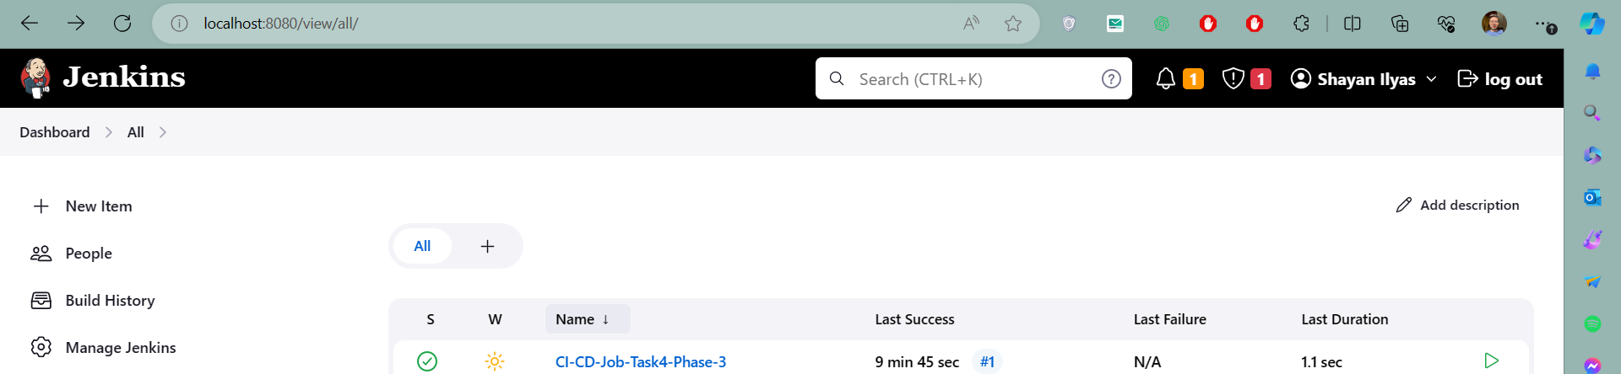

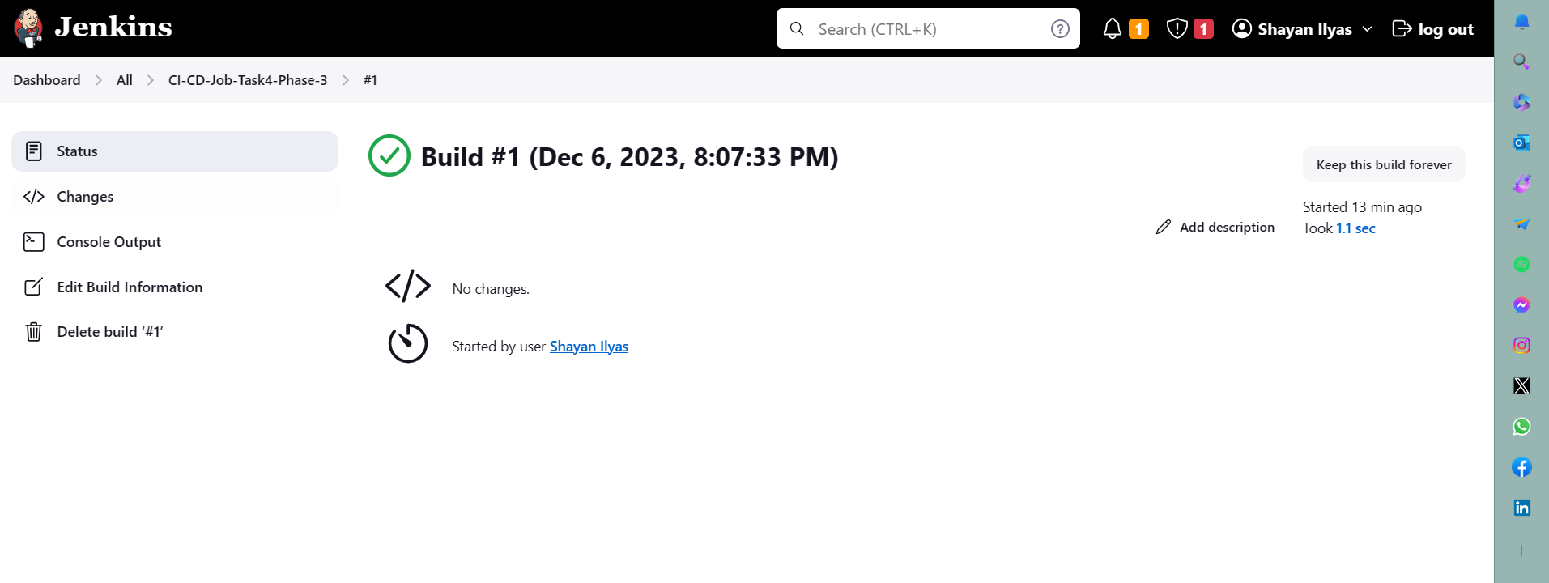

**Created docker file and Jenkins file for semgroup for static analysis and uploaded on github**



